CHESTER HILL HIGH SCHOOL YEAR 12 HALF YEARLY EXAM – CHEMISTRY

1. Ethanol is a versatile and useful chemical. Which of the following processes is not an example of the
use of ethanol

A oxidation as a fuel
B miscible with water as a solvent
C dehydration as a feedstock
D fermentation

2. Ethene is produced on a commercial scale by which process?

A condensation
B catalytic cracking
C polymerization
D hydrogenation

3. Which of the following sets contain an acidic, a basic and a neutral substance?

A washing soda, pineapple juice, sucrose solution
B soda water, lemonade, seawater
C baking soda, caustic soda, orange juice
D pure water, ammonia, limewater

- In your chemistry course, you performed a first hand investigation using spirit burners to determine
the heat of combustion of alcohols. Select the statement that correctly identifies an issue associated
with this experiment:

A the technique is invalid as too much heat is lost to the surroundings
B heat loss can be considerably reduced by using polystyrene foam calorimeters
C accuracy can be improved by using spirit burners with new wicks for each run
D alcohols are too volatile to be safely used in spirit burners

5. The molecular formula for 2-pentanol is:
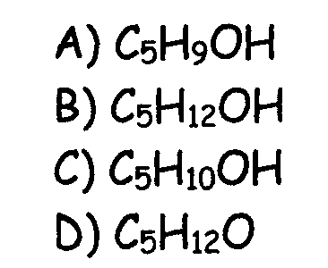

6. The table shows the heat of combustion for 4 different alcohols
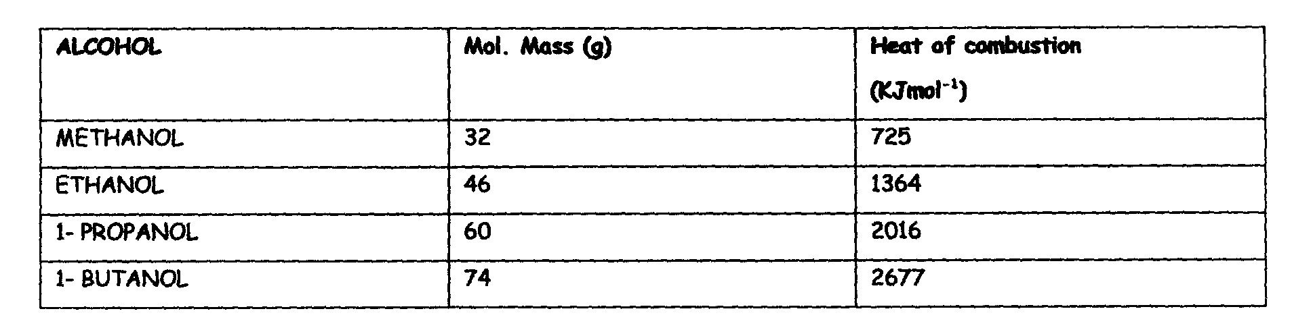

The alcohol with the greatest heating value in KJ/kg is:

A methanol
B ethanol
C 1-propanol
D 1-butanol

7. The emission of beta rays by an element results in the loss of

A energy
B electrons
C helium nuclei
D stability

8. Consider the reaction described by the equation below


This reaction is an example of:

A polymerization
B hydration
C dehydration
D addition

9. What is the oxidation state of manganese in potassium permanganate, KMnO₄

A -1
B +3
C +7
D +8

10. Which of the following are significant industrial sources of sulfur dioxide?

A lightning and bacteria
B bacteria and volcanoes
C internal combustion engine and air conditioning units
D coal burning stations and metal ore smelting

11. What is the pH of a 1.5 x 10⁻³ mol/L solution of HCl?

A 4.0
B 1.5
C 3.0
D 2.8
12. Some household cleaners contain strong bases like NaOH. A student tested several cleaning
solutions with Litmus and recorded the results in the table:

Cleaning solution | Colour of blue litmus | Colour of red litmus
X | Blue | Red
Y | Blue | Blue
Z | Red | Red

The cleaning solution most likely to contain NaOH is:

A X and Y
B Y only
C Z only
D X and Z

13. Which of these acids does NOT occur naturally?

A hydrobromic acid
B hydrochloric acid
C acetic acid
D citric acid

14. Carbon-14 is an unstable isotope of carbon because:

A it has a half life of about 6000 years
B its nucleus has an atomic number greater than 83
C the neutron to proton ratio is too great
D it has more neutrons than protons

15. The systematic name given to the monomer vinyl chloride is:

A chloroethene
B 1,2-dichloroethene
C chloroethene
D 1,2-dichloroethane

PART B ATTEMPT ALL QUESTIONS ON THE SPACE PROVIDED

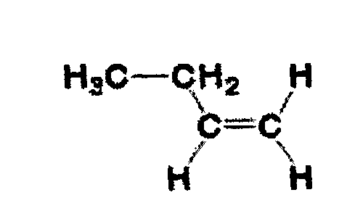
Question 1 (7 marks)

A polymer can be made from the molecule shown:

a. Identify this substance…………………………….. 1

b. Construct a structural formula for 3 units of the polymer formed by this substance 1

c. Assess the suitability of this polymer for the use of fruit juice containers 2

………………………………………………………………………………………………………………

………………………………………………………………………………………………………………

………………………………………………………………………………………………………………

………………………………………………………………………………………………………………

d. Identify this type of polymerisation reaction……………………………………………………........... 1

e. Identify a substance that can be used in the future to replace our reliance on the petroleum industry and
name the process involved in its production 2

………………………………………………………………………………………………………………

………………………………………………………………………………………………………………

Question 2 (3 marks)

Outline the origin and effects of acid rain in industrial areas

………………………………………………………………………………………………………………

………………………………………………………………………………………………………………

………………………………………………………………………………………………………………

………………………………………………………………………………………………………………

………………………………………………………………………………………………………………

………………………………………………………………………………………………………………

Question 3 (6 marks)

a. Elements that have been discovered in the past 50 years are described as recently produced. Describe
how a named element has been produced or discovered in recent times

………………………………………………………………………………………………………………

………………………………………………………………………………………………………………
………………………………………………………………………………………………………………

………………………………………………………………………………………………………………

………………………………………………………………………………………………………………

………………………………………………………………………………………………………………

b. Identify an isotope used in medicine or industry, discuss the benefits associated with its use in today’s
society (3)
………………………………………………………………………………………………………………

………………………………………………………………………………………………………………

………………………………………………………………………………………………………………

………………………………………………………………………………………………………………

Question 4 (4 marks)

You have studied one of the following cells: LEAD ACID BATTERY or DRY CELL. Choose one of the cells and answer the following:

a. State one environmental impact associated with the cell you have chosen 1

………………………………………………………………………………………………………………

………………………………………………………………………………………………………………

b. Describe the chemistry of the cell you have studied 3

………………………………………………………………………………………………………………

………………………………………………………………………………………………………………

………………………………………………………………………………………………………………

………………………………………………………………………………………………………………

Question 5 (3 marks)

One of the many uses of ethanol is as a solvent of both polar and non-polar substances. Account for the use of ethanol in these ways

………………………………………………………………………………………………………………

………………………………………………………………………………………………………………

………………………………………………………………………………………………………………

………………………………………………………………………………………………………………

………………………………………………………………………………………………………………

………………………………………………………………………………………………………………
Question 6 (3 marks)

When 1.5 L of hydrogen chloride gas and 1.8 L of ammonia gas are mixed, a white solid of ammonium chloride is formed

a. Write a balanced equation to represent the reaction 1

………………………………………………………………………………………………………………

b. Calculate the mass of ammonium chloride formed if the gas volumes were measured at RTP
(25ºC, 100 KPa)

………………………………………………………………………………………………………………

………………………………………………………………………………………………………………

………………………………………………………………………………………………………………

………………………………………………………………………………………………………………

………………………………………………………………………………………………………………

………………………………………………………………………………………………………………

Question 7 (4 marks)

Equilibrium exists between gaseous and dissolved carbon dioxide in water as shown by the following equation:

CO_{2(g)} ⬅===➔ CO_{2(aq)}

With reference to Le Chaterlier’s Principle explain the following:

a. Fizzing occurs when a bottle of carbonated drinks is opened 2

………………………………………………………………………………………………………………

………………………………………………………………………………………………………………

………………………………………………………………………………………………………………

………………………………………………………………………………………………………………

………………………………………………………………………………………………………………

b. It is observed that the fizzing is less if the bottle is kept under refrigeration rather than at room 2
temperature. Deduce whether the dissolving process is exothermic or endothermic. Explain your
reasoning

………………………………………………………………………………………………………………

………………………………………………………………………………………………………………

………………………………………………………………………………………………………………
Question 8 (5 marks)

An acid we call HX, was prepared by dissolving 0.1 moles of it in enough water to make 1 L of the solution. A pH meter shows that the solution has a pH of 3.5.

a. Calculate the concentration of [H⁺] for the solution 1

………………………………………………………………………………………………………………

………………………………………………………………………………………………………………

………………………………………………………………………………………………………………

b. Solutions of 3 acids were prepared. Each of the solutions had the same concentration (0.01 mol/L).
the diagrams below illustrate this
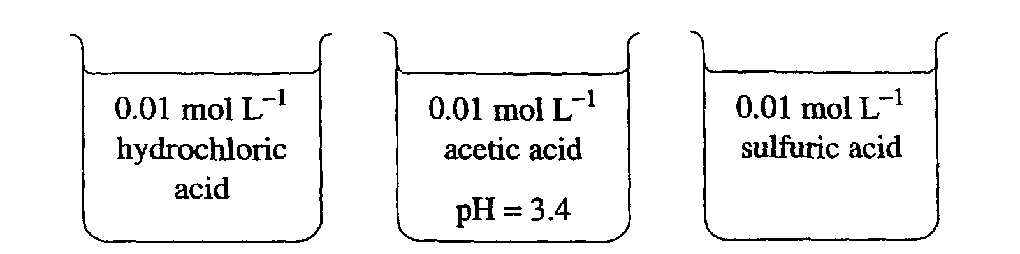

Calculate the pH of the HCl acid solution 1

………………………………………………………………………………………………………………

c. compare the pH of the sulfuric acid solution to that of the hydrochloric acid. Justify your answer. No
calculations are required 2

………………………………………………………………………………………………………………

………………………………………………………………………………………………………………

………………………………………………………………………………………………………………

………………………………………………………………………………………………………………

………………………………………………………………………………………………………………

d. Identify and name an acid that is commonly called an organic acid present in many fruits 1

………………………………………………………………………………………………………………

………………………………………………………………………………………………………………

